Ahmet Buğra Ertürk
0086877
ACWR 106-17
March 21, 2025
Position Paper Draft
Word Count: 1241

Semi-Supervised Learning as a Better Alternative to Weakly Supervised Learning to Train Medical Image Segmentation Models with Insufficiently Labeled Data

With developments in artificial intelligence (AI), AI models have begun to be used in other fields as well. Medicine is one of the areas that use AI to detect disorders by medical image segmentation (MIS). Nevertheless, similar to all other AI models, MIS models needs massive data with labels, since complex training algorithms with learnable variables run behind the learning models, and these variables change depending on the difference between prediction and label. In the domain of medicine, there is an abundance of unlabeled medical data because the manual annotation of the medical data is not easy, as it costs physicians considerable time and effort; therefore, precisely labeling whole data distracts the model from full supervision. [1]. However, where data is insufficiently labeled, MIS models cannot work well, since they would not learn enough. This issue causes the medical model not to separate biological differences precisely and it may fail to detect diseases. To overcome this problem, researchers use some state-of-the-art methods such as semi-supervised learning (SSL) [1] and weakly supervised learning (WSL) [2]. While SSL mostly uses unlabeled data, WSL does not need pixel-level annotation, so labeling in weakly annotated data takes less time as labeling in fully annotated data with the drawback of resulting in a worse performance [1], [2]. SSL is a better option than WSL as a solution for insufficiently labeled data in the domain of MIS in terms of accuracy and adaptability.
MIS holds great potential for early detection of diseases, but the lack of labeled data is an obstacle regarding this because learning algorithms need to know the content of the data. Non-physicians cannot annotate medical data while physicians do not have enough time, so enough labeled data cannot be provided to MIS models to learn [2]. Also, in some cases, a dataset contains an amount of data that a human can not annotate, so labeling all data becomes impossible. When trying to train an MIS model with only the available labeled data, MIS models are overfitting [4]. Although overfitting seems good at first glance, the model cannot make a successful prediction for the data in the validation dataset since some situations have never been seen by the model during training, so the model can not identify them, causing an increment in true-negative and false-positive cases. Because overfitted MIS models cannot make good predictions, using them in medicine can have risks. For example, the model can call a healthy cell cancerous, and vice versa, and the mistake can cause serious consequences. Concisely, the available labeled data in medicine is insufficient to train MIS models so to use them as a tool in medicine, some state-of-the-art methods have to be used.
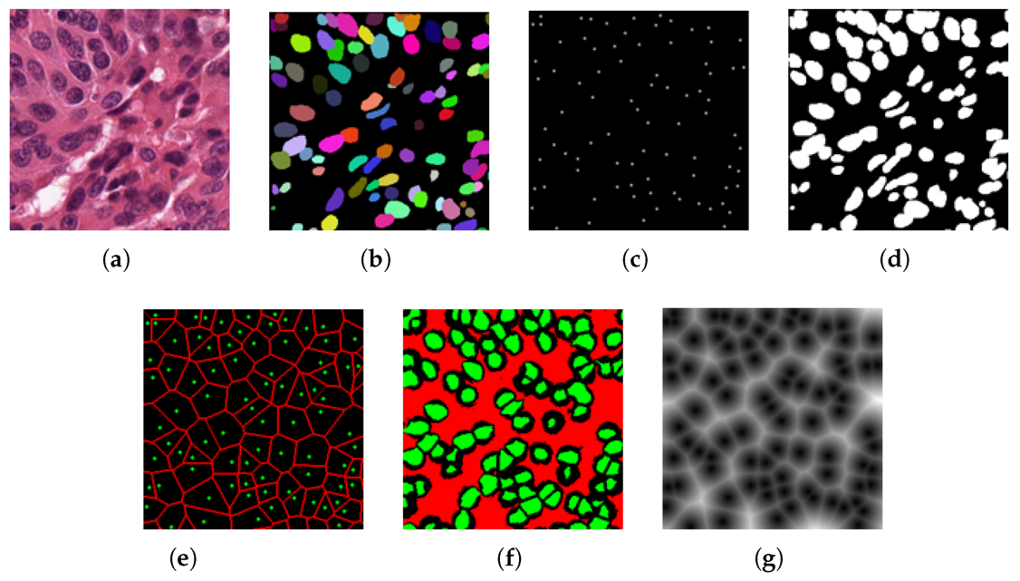
Fig. 1. Different labels for the MIS task: (a) Input image, (b) Pixel-level instance label, (c) Point annotation, (d) Binary mask, (e) Voronoi label, (f) Cluster label, and (g) Distance map. While (b) and (d) are fully labels, (c), (e), (f), and (g) are weakly labels. (Adapted from [3])
In WSL, labels are imprecise. Imprecise labels need less effort and time than fully precise labeling. Additionally, weakly annotation does not require a high level of morphological knowledge, meaning non-physicians can also annotate data, making weakly annotation one of the easiest ways of collecting labels. For example, point annotation decreases the annotation time of a dataset by %86.84 [3]. Therefore, available unlabeled data in medicine can be labeled with this method and it can solve insufficiently labeled data problem. In Fig. 1, among all weakly annotation methods, only (c) and (e) are more convenient compared to fully labeling— seen in images (b) and (d) —, while (f) and (g) require as much effort to achieve the level of labeling as (b) and (d). Hence, in WSL, achieving a good result with (c) and (e) is the most important aim, since accurately predicting boundaries is challenging in MIS training with point annotation [3], as point annotations provide no information about boundaries. In summary, although weakly annotation takes less time and effort, it has limitations in determining boundaries.
SSL can use unlabeled data, so it does not need fully labeled data, but the labeled part of the data has to be precise similar to Fig. 1 (b) and (d). To do it, there are many state-of-the-art methods and most of them use multiple models and extract the common results of these models [1]. For example, in a dataset of 100 datapoints where only 20 datapoints are labeled, MIS models first pre-train on the 20 labeled datapoints, then, they choose 5 of the 80 unlabeled datapoints and use attention algorithms between pre-trained models to create labels for them, called pseudo-labelling. This pseudo-labelling process continues until all datapoints have labels, while each iteration fixes the previous labels created by the models, and at the end the whole labeled data trains a final model [5]. Using multiple models and attention algorithms requires high performance computing; however, it does not need physicians’ time and effort since available labeled data in medicine is sufficient to train semi-supervised MIS models. Briefly, SSL needs high performance, which results in low technical efficiency, but its prediction can separate boundaries since labeled data is sufficient for SSL.
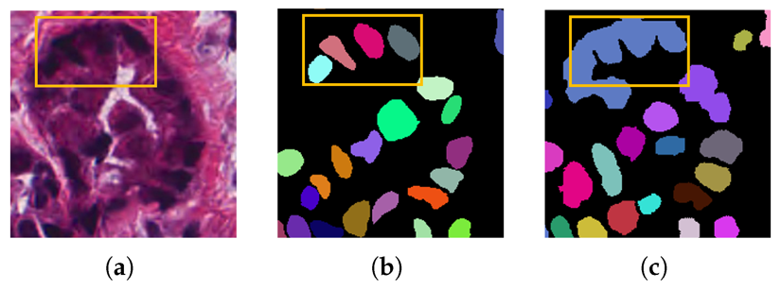
Fig. 2. A bad case of segmenting adjacent nuclei: (a) Input image, (b) Ground truth, (c) Predicted instance map. (Adapted from [3])
Although SSL requires more computer power compared to WSL, it has higher accuracy. Statistically, comparing them with the Dice_{obj} metric which evaluates the similarity between prediction and ground-truth [3], when both models use the MoNuSeg dataset, Dice_{obj} of a SSL model is 0.826 [4] while a WSL model’s is 0.772 [3]. The reason for this difference is boundary precision, WSL models can make mistakes in recognizing boundaries of the nuclei [2]. In addition to numerically lower performance, wrong boundary prediction has potentially dangerous predictions; for instance, in Fig. 2, the size and shape of nuclei in (c) are completely different from ground-truth (b), while benign and malignant tumors are distinguished on the basis of nucleus’s shape and size [4]. Hence, WSL models cannot perform sufficiently to be used in real-life scenarios, but SSL models can provide some preliminary information to physicians. Also, because of the working mechanism, SSL models can use new data since it does not need labeled data anymore, but for WSL, new data has to be annotated. Consequently, SSL models provide a more sustainable approach with the ability to adapt to new data.
Despite all these advantages of SSL models, they have some limitations. One of them is that as mentioned before, only some part of the data has labels, but this labeled part may not contain important information such as cancer. In this scenario, the model cannot learn what type of cells have cancer, since it has no knowledge about it. To overcome this, it may be necessary to intervene in the active learning process or to label new data. Physicians are careful to label all kinds of data at the initial time of labeling or the data is added to the model by the doctors in a short span of time afterwards. These processes take experts’ time, but it is not as time-demanding as fixing the wrong predictions of WSL. Thus, this problem is solvable which renders SSL preferable to WSL in terms of accuracy and time efficiency.
To sum up, while both SSL and WSL approaches aim to address the challenge of insufficient labeled data in medical image segmentation, SSL proves to be the more effective and sustainable solution. Despite requiring higher computational resources, its accuracy makes it more reliable. Furthermore, it can use new data without additional annotation. Therefore, SSL is a more efficient approach with the balance between performance, scalability, and clinical applicability. As one of the hottest topics in the MIS field, SSL will become more and more efficient and suitable for MIS processes with the major breakthroughs in AI.

References
- J. Liu, C. Desrosiers, D. Yu, and Y. Zhou, “Semi-Supervised Medical Image Segmentation Using Cross-Style Consistency With Shape-Aware and Local Context Constraints,” IEEE Transactions on Medical Imaging, vol. 43, no. 4. Institute of Electrical and Electronics Engineers (IEEE), pp. 1449–1461, Apr. 2024. doi: 10.1109/tmi.2023.3338269.
- A. K. Tyagi, V. Mishra, P. A. P., and Mausam, “Guided Prompting in SAM for Weakly Supervised Cell Segmentation in Histopathological Images,” 2023, arXiv. doi: 10.48550/ARXIV.2311.17960.
- Y. Mo, L. Chen, L. Zhang, and Q. Zhao, “Weakly Supervised Nuclei Segmentation with Point-Guided Attention and Self-Supervised Pseudo-Labeling,” Bioengineering, vol. 12, no. 1. MDPI AG, p. 85, Jan. 17, 2025. doi: 10.3390/bioengineering12010085.
- [1] H. Li, J. Zhong, L. Lin, Y. Chen, and P. Shi, “Semi-supervised nuclei segmentation based on multi-edge features fusion attention network,” PLOS ONE, vol. 18, no. 5. Public Library of Science (PLoS), p. e0286161, May 25, 2023. doi: 10.1371/journal.pone.0286161.
- X. Zhang, J. Zhang, J. Shao, H. Li, X. Liu, and M. Jia, “A semi‐supervised segmentation network fusing pseudo‐label with multi‐level feature consistency correction for hard exudates,” IET Image Processing, vol. 18, no. 13. Institution of Engineering and Technology (IET), pp. 4411–4421, Oct. 22, 2024. doi: 10.1049/ipr2.13262.

